**Report about conducted load test**

**Date:** 04/07/2022

**Author:** Vladyslav Kliucharov

**Application:** BlogEngine.NET version 3.2

**Environment:** Test Environment VirtualBox (Version 6.1.34 r150636 (Qt5.6.2))

**Test Environment configuration(RAM, CPU etc.):**

|  |  |
| --- | --- |
| **Processor** | 11th Gen Intel(R) Core(TM) i7-1185G7 @ 3.00GHz 3.00 GHz (4 core) |
| **RAM** | 4 GB |
| **Hard Disk** | 60 GB |
| **Operating System** | Windows 10 Enterprise (21H2) |

1. **Why such testing was conducted:**

The report is included two methods of testing:

1. Smoke testing - was conducted to verification that the crucial functions of a program can be run and executed in the main workflow

2. Scalability Testing- was conducted to define and ensure that the system can handle the scaling of CPU and RAM performance goals

1. **Test script description:**

The features to be tested have been logically grouped to be covered by 3 threads of users "Admin script", "Editor script" and "Anonymous script". These scenarios were combined in one script followed by load requirement analysis for the modules. The below table captures the features covered by each script. The implement probabilities usage was divided by percentages for all threads (shown below tables):

|  |  |
| --- | --- |
| **Admin script** | **Editor script** |
|  |  |

|  |  |  |
| --- | --- | --- |
|  | **Anonymous script** |  |
|  |  |  |

Scenario to implement probabilities usage:

|  |  |
| --- | --- |
| 1. Home Page: 15%  2. Open Random Date: 10%  3. Open Predefined Date: 30%  4. Search by Name: 30%  5. Open Large Calendar: 10%  6. Open Contacts: 5% | 1. Open Random page (yes/no): 50% / 50%  2. Open post (yes/no): 80% / 20%  3. Random or First (yes/no): 65% / 35%  4. Comment (yes/no): 20% / 80% |

1. **Tests:**  
   **Test run preconditions:**

* CSV file with Random dates
* Warmup script was running before each test run
* Before each new test script run, the webserver was reloaded, the test executed in NON-GUI mode
* Monitoring key performance indicator for the tests:

**Throughput (Max)**

**Error rate**

**Response time (Average)**

**Response time (Median)**

**90th Percentile (Mean)**

**95th Percentile (Mean)**

* From 3 runs in ”Task7” were defined the comfort zone was defined as 45 users
* Monitoring key performance indicator from Task 7 (the best value from 3 runs)

|  |  |  |  |  |  |  |  |  |
| --- | --- | --- | --- | --- | --- | --- | --- | --- |
|  | **CPU** | **RAM** | **Throughput (Max)** | **Error rate** | **Response time (Average)** | **Response time (Median)** | **90th Percentile (Mean)** | **95th Percentile (Mean)** |
| Load model (Task 7) | 2 Core | 8 GB | 13.00 Req/s | 5.78% | 3.59 ms | 2.89 ms | 18.7 sec | 20.9 sec |

* There were used 6 Scale Models**:**

|  |  |  |
| --- | --- | --- |
|  | **CPU** | **RAM** |
| **Scale Model 1** | 1 | 8GB |
| **Scale Model 2** | 2 |
| **Scale Model 3** | 3 |

|  |  |  |
| --- | --- | --- |
|  | **CPU** | **RAM** |
| **Scale Model 4** | 2 | 2 GB |
| **Scale Model 5** | 4 GB |
| **Scale Model 6** | 8 GB |

Scenarios model (was used similarly for all scale) the value was getting from Task7 regular load model by got results of previous test runs

|  |  |  |  |  |  |
| --- | --- | --- | --- | --- | --- |
| **Thread Group** | **Maximum number of simultaneous users** | **Ramp-Up period** | **Test duration** | **Probabilities usage** | **Number of posts quantity** |
| Thread Group (Admin users) | 2 | 100 | 600 (sec.) | Pre-Defined | 1000 |
| Thread Group (Editor users) | 10 | 50 | 600 (sec.) | Pre-Defined | 1000 |
| Thread Group (Anonymous users) | 35 | 175 | 600 (sec.) | Pre-Defined | 1000 |

1. **Short summary on conducted tests:**

The server worked stable with 1 CPU, in case of 2,3 CPUs viewed unstable server work. according to the received test results by 6 runs for 1,2,3 CPU, the best result was defined for 1 CPU (view result in "detailed test results"), in the case of 2,3 CPUs test results were unstable every run. CPUs are growing to 100% the quantity of user's request is falling after reaching server timeout. The next 6 runs use params with 2,4,8 GB RAM and 2 CPUs. Scaling of the quantity of RAM has no significant influence on system work. The appropriate parameters for server work are 1 CPU and 8GB of RAM.

1. **Detailed test results:**

According to the scalability testing results behavior is described below:

|  |  |  |  |  |  |  |  |  |  |  |  |  |
| --- | --- | --- | --- | --- | --- | --- | --- | --- | --- | --- | --- | --- |
|  | **Run 1 Scale Model 1** | **Run 2 Scale Model 1** | **Run 1 Scale Model 2** | **Run 2 Scale Model 2** | **Run 1 Scale Model 3** | **Run 2 Scale Model 3** | **Run 1 Scale Model 4** | **Run 2 Scale Model 4** | **Run 1 Scale Model 5** | **Run 2 Scale Model 5** | **Run 1 Scale Model 6** | **Run 2 Scale Model 6** |
| **CPU** | 1 Core |  | 2 Core |  | 3 Core |  | 2 Core |  | 2 Core |  | 2 Core |  |
| **RAM** | 8 GB |  | 8 GB |  | 8 GB |  | 2 GB |  | 4 GB |  | 8 GB |  |
| **Throughput (Max)** | 16.80 Req/s | 17.00 Req/s | 16.40 Req/s | 16.20 Req/s | 16.80 Req/s | 14.60 Req/s | 17.40 Req/s | 16.60 Req/s | 13.80 Req/s | 14.00 Req/s | 16.40 Req/s | 16.20 Req/s |
| **Error rate** | 0 | 0 | 4.76% | 5.03% | 2.63% | 7.36% | 3.93% | 4.53% | 9.44% | 8.92% | 4.76% | 5.03% |
| **Response time (Average)** | 3.87 ms | 3.32 ms | 2.60 ms | 2.85 ms | 3.60 ms | 2.39 ms | 3.33 ms | 2.90 ms | 2.09 ms | 2.26 ms | 2.60 ms | 2.85 ms |
| **Response time (Median)** | 2.89 ms | 2.58 ms | 2.03 ms | 2.35 ms | 2.70 ms | 1.96 ms | 2.51 ms | 2.15 ms | 1.77 ms | 1.94 ms | 2.03 ms | 2.35 ms |
| **90th Percentile (Mean)** | 1.49 sec | 2.72 sec | 20.9 sec | 22.2 sec | 1.92 sec | 52.0 sec | 17.0 sec | 31.5 sec | 1.16 min | 58.5 sec | 20.9 sec | 22.2 sec |
| **95th Percentile (Mean)** | 1.86 sec | 3.41 sec | 21.7 sec | 26.9 sec | 2.52 sec | 53.4 sec | 19.6 sec | 32.7 sec | 1.31 min | 59.1 sec | 21.7 sec | 26.9 sec |

**Test Run #1 (Scale Model 1)**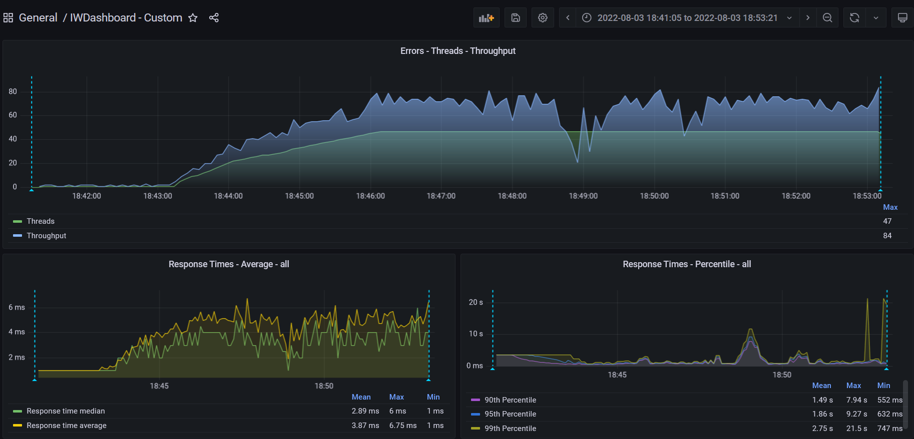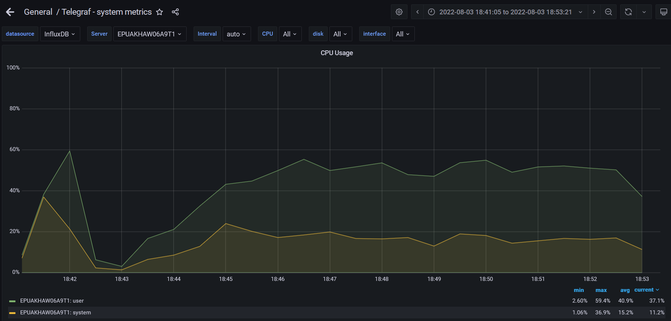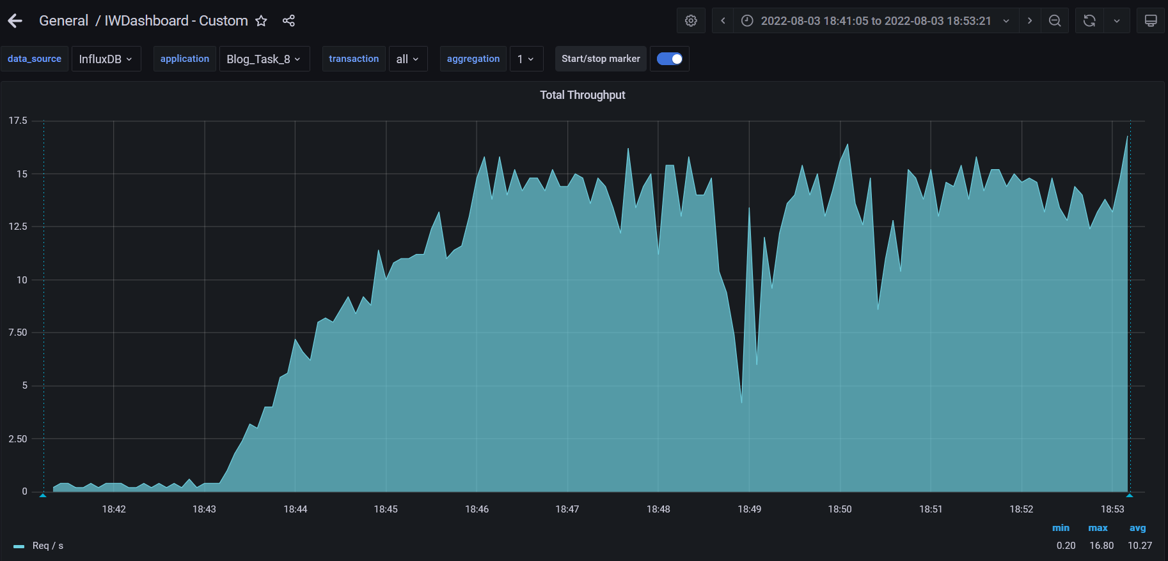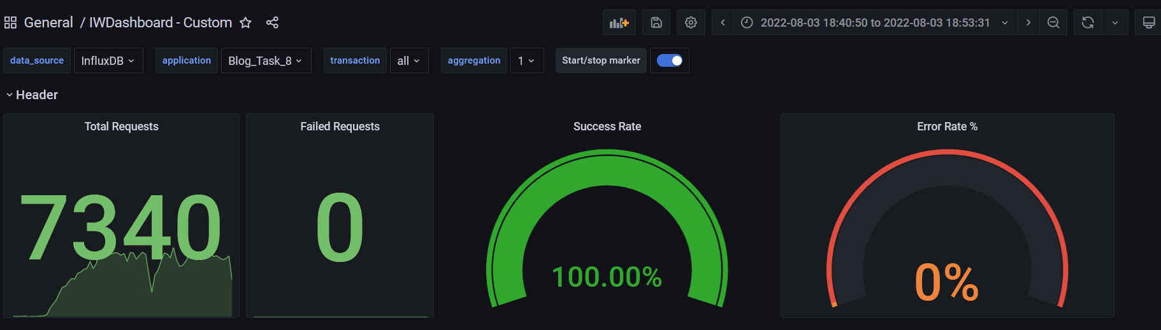

**Test Run #2 (Scale Model 1)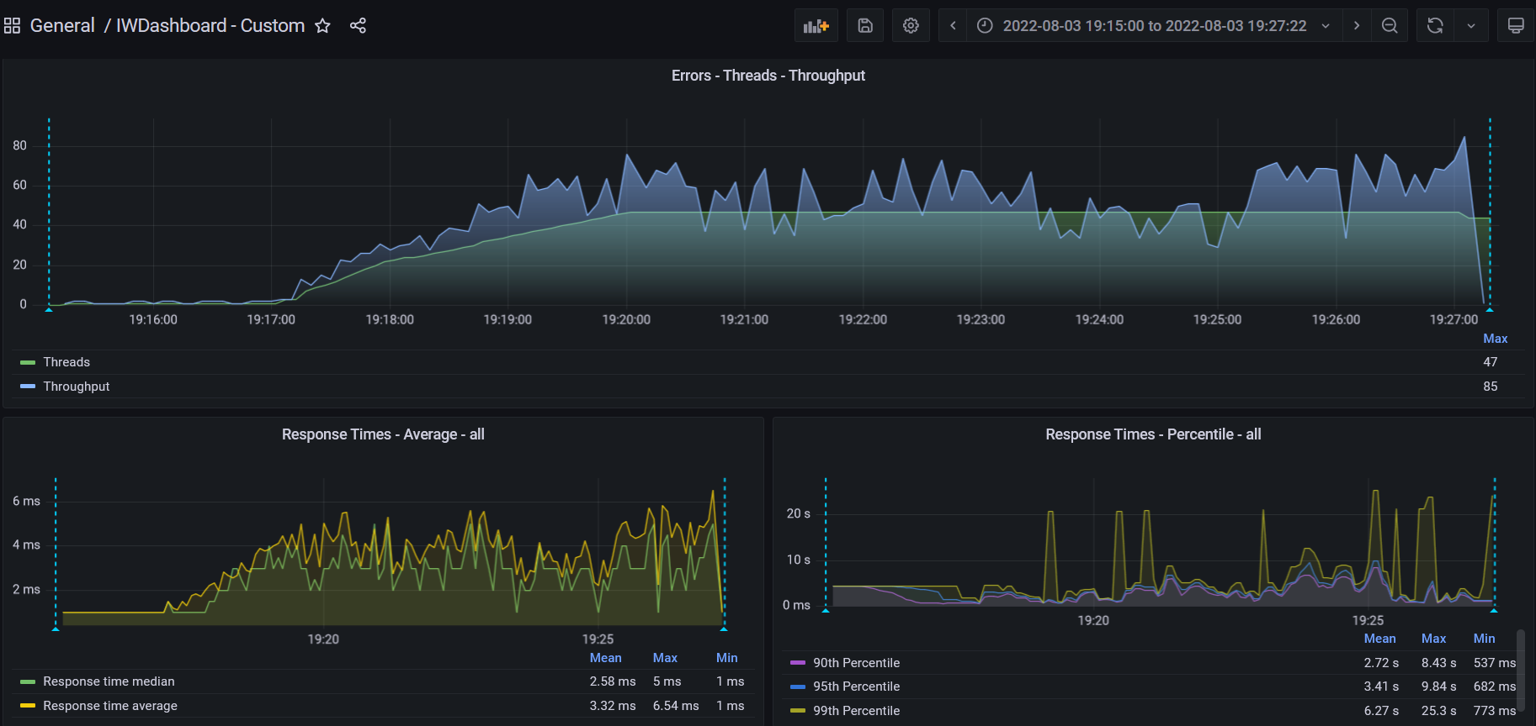**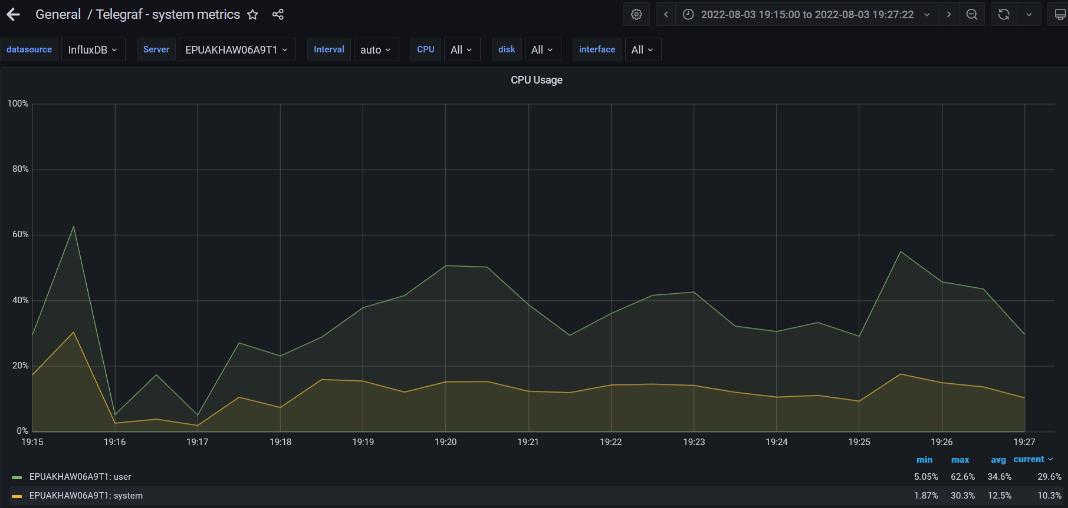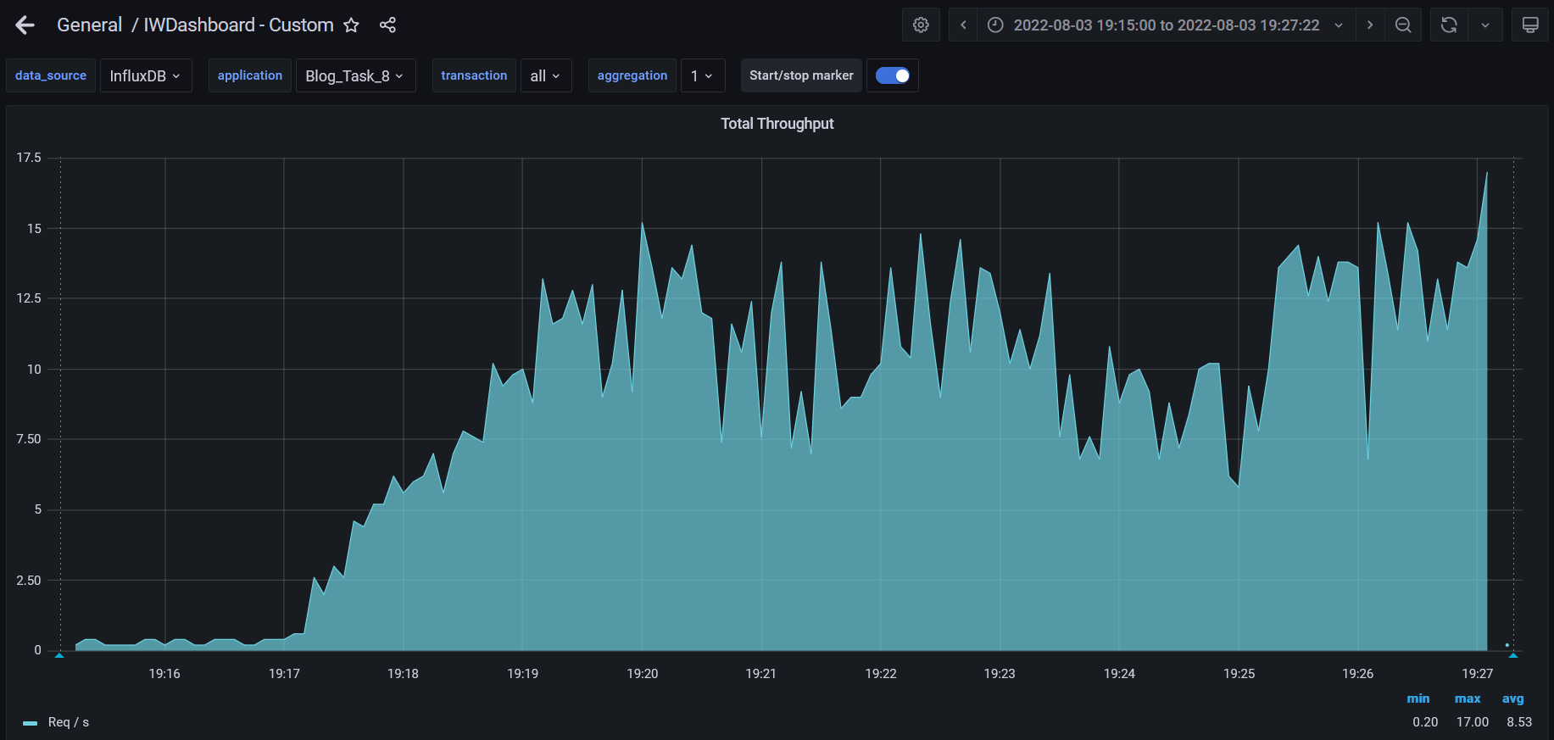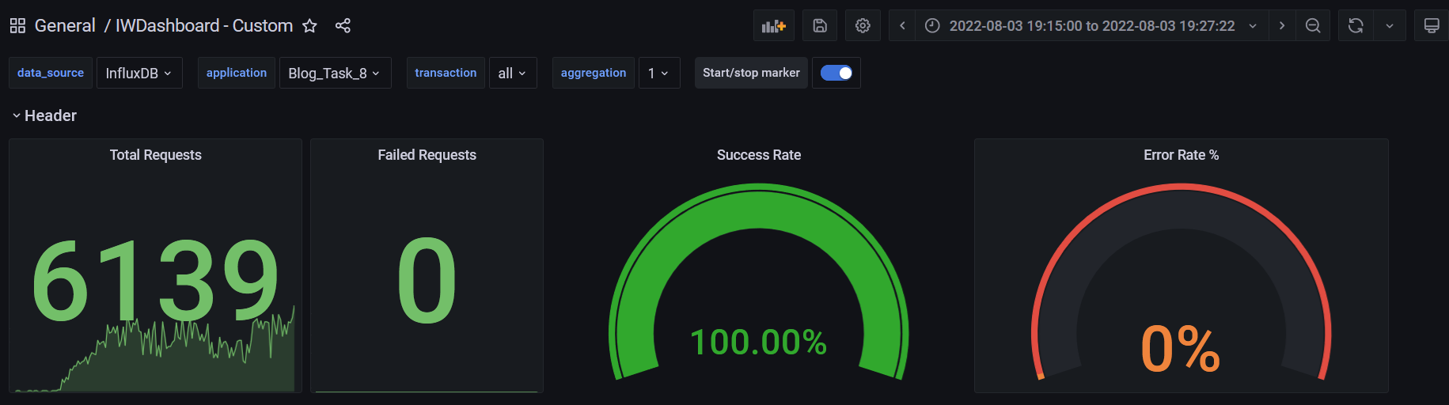

**Test Run #1 (Scale Model 2)**

**Detailed error report**

|  |  |  |
| --- | --- | --- |
| Response Code | Transaction | Error count |
| 500 | Transaction Controller (Open Home Page Anonymous)  Transaction Controller (Open PredefineDate)  Transaction Controller (Open Profile Page)  Transaction Controller (Open RandomDate)  Transaction Controller (Save Post)  Transaction Controller (Search By Name) | 1  2  1  1  17  4 |
| 404 | Transaction Controller (Open Home Page Anonymous)  Transaction Controller (Open PredefineDate)  Transaction Controller (Open RandomDate)  Transaction Controller (Search By Name) | 5  8  3  7 |
| Non HTTP response code: java.net.SocketTimeoutException | Transaction Controller (Edit Post)  Transaction Controller (Login)  Transaction Controller (Open Contacts)  Transaction Controller (Open Date)  Transaction Controller (Open Home Page Anonymous)  Transaction Controller (Open Home Page)  Transaction Controller (Open Large Calendar)  Transaction Controller (Open Post)  Transaction Controller (Open PredefineDate)  Transaction Controller (Open Profile Page)  Transaction Controller (Open RandomDate)  Transaction Controller (Open User Page)  Transaction Controller (Save Post)  Transaction Controller (Search By Name) | 4  1  2  2  11  2  4  5  16  1  8  1  1  20 |
| Non HTTP response code: java.net.URISyntaxException | Transaction Controller (Edit Post) | 5 |

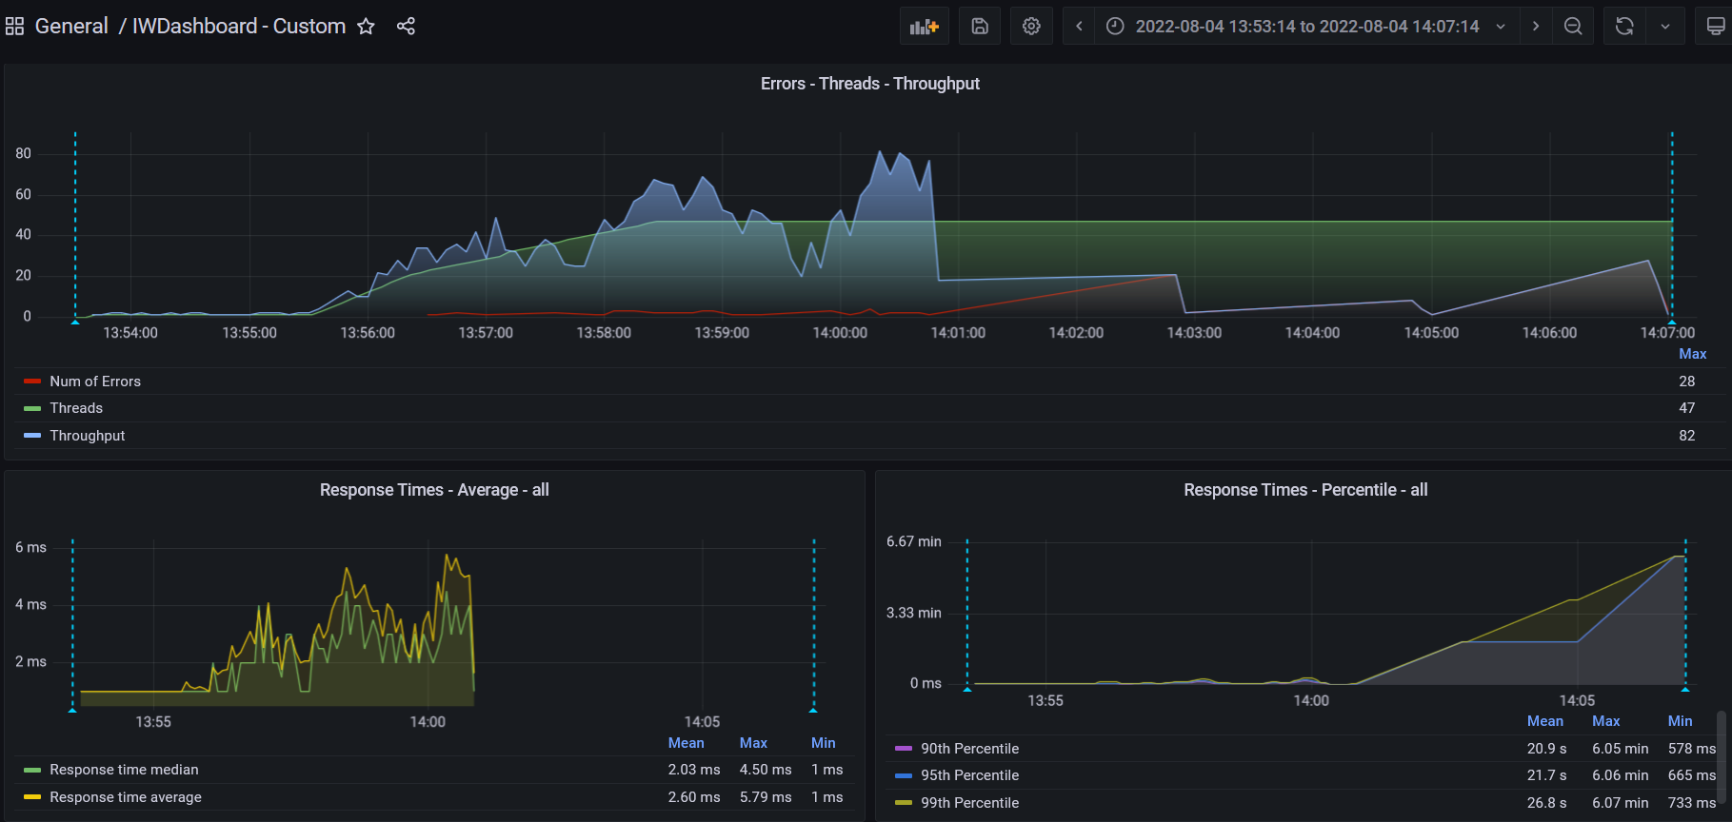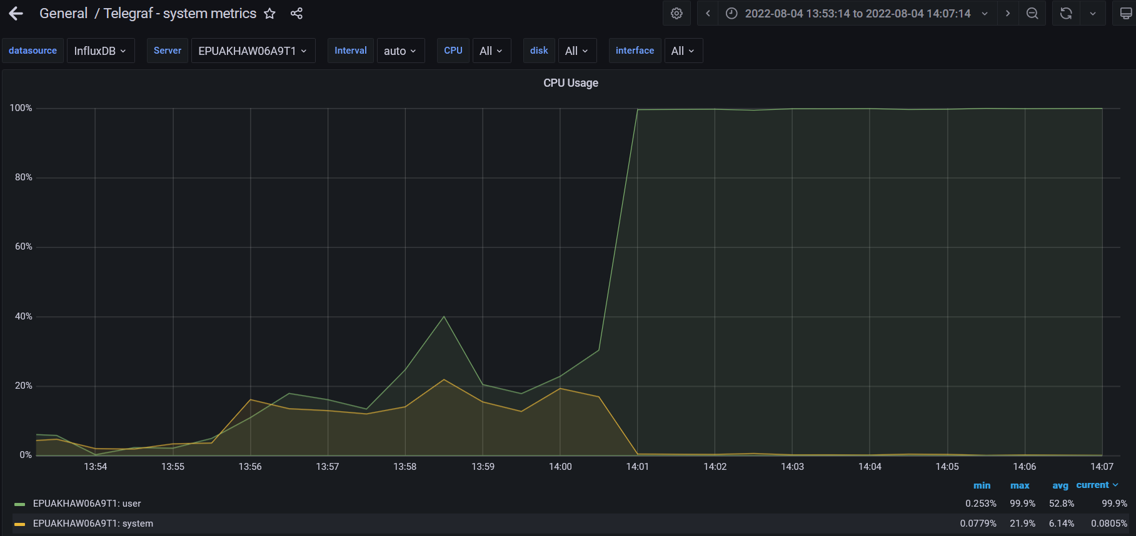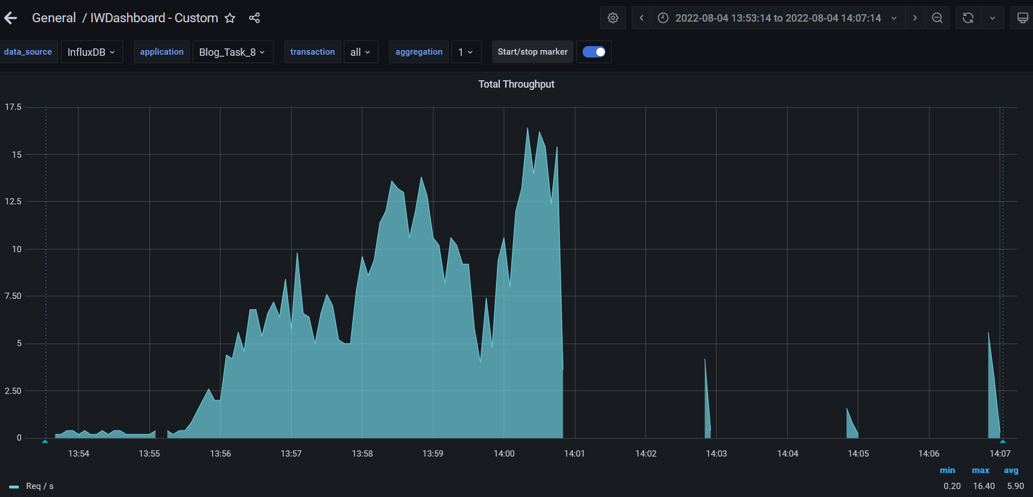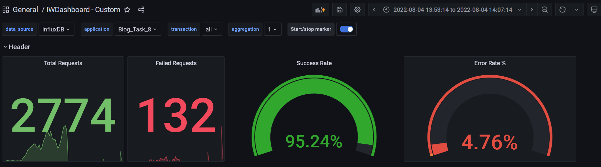

**Test Run #2 (Scale Model 2)**

**Detailed error report**

|  |  |  |
| --- | --- | --- |
| Response Code | Transaction | Error count |
| 500 | Transaction Controller (Open PredefineDate)  Transaction Controller (Save Post) | 1  10 |
| 404 | Transaction Controller (Open Home Page Anonymous)  Transaction Controller (Open PredefineDate)  Transaction Controller (Open RandomDate)  Transaction Controller (Search By Name) | 7  15  2  9 |
| Non HTTP response code: java.net.SocketTimeoutException | Transaction Controller (Add User)  Transaction Controller (Edit Post)  Transaction Controller (Open Contacts)  Transaction Controller (Open Date)  Transaction Controller (Open Home Page Anonymous)  Transaction Controller (Open Home Page)  Transaction Controller (Open Large Calendar)  Transaction Controller (Open Post)  Transaction Controller (Open PredefineDate)  Transaction Controller (Open Profile Page)  Transaction Controller (Open RandomDate)  Transaction Controller (Open User Page)  Transaction Controller (Save Post)  Transaction Controller (Search By Name) | 1  3  5  2  7  2  4  5  18  1  8  2  2  19 |
| Non HTTP response code: java.net.URISyntaxException | Transaction Controller (Edit Post) | 5 |

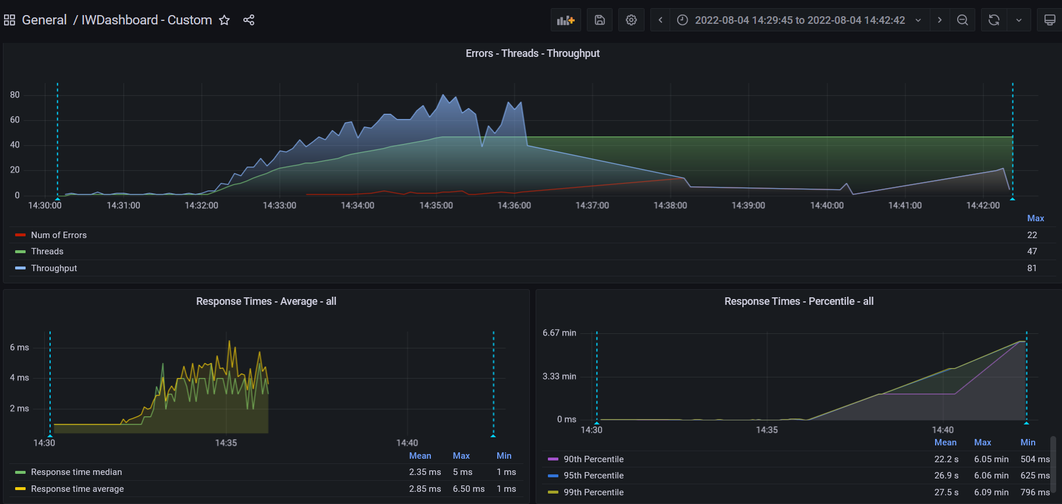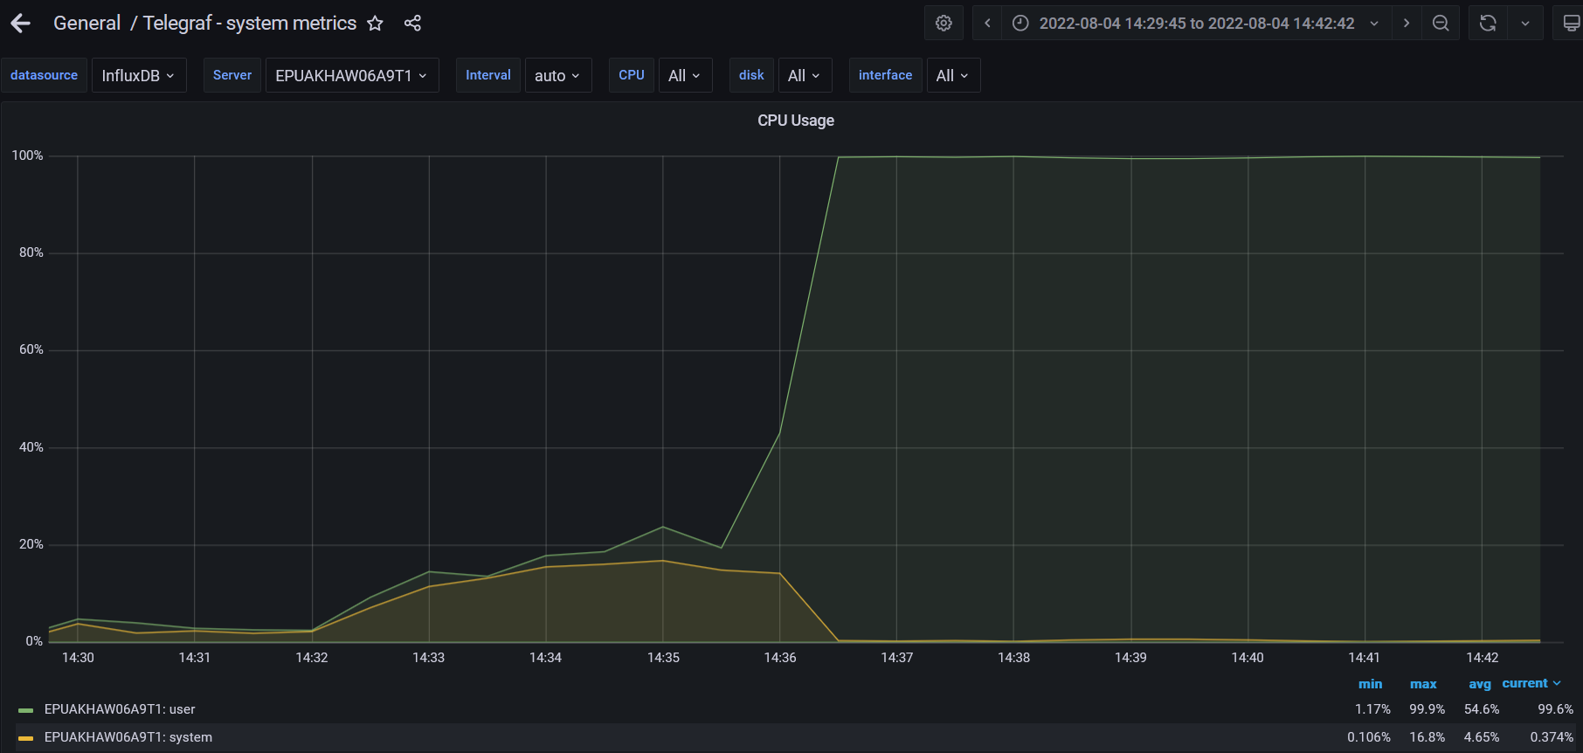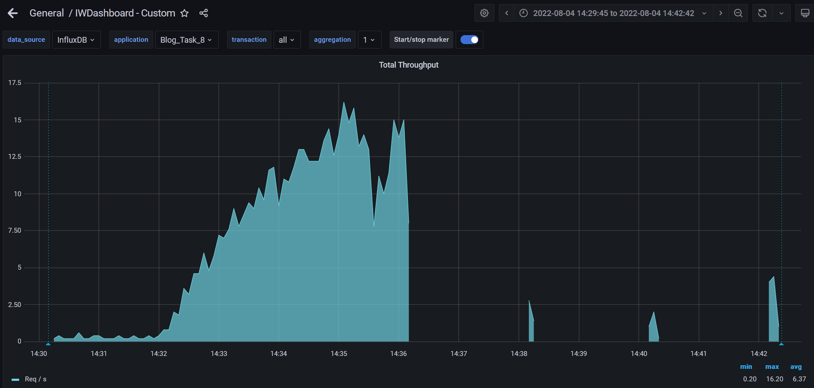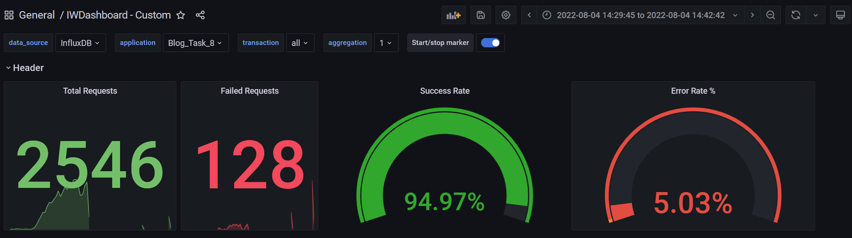

**Test Run #1 (Scale Model 3)**

**Detailed error report**

|  |  |  |
| --- | --- | --- |
| Response Code | Transaction | Error count |
| 500 | Transaction Controller (Open Date)  Transaction Controller (Open Home Page Anonymous)  Transaction Controller (Open Large Calendar)  Transaction Controller (Open PredefineDate)  Transaction Controller (Open RandomDate)  Transaction Controller (Save Post)  Transaction Controller (Search By Name) | 15  2  52  12  37  1  6 |
| 404 | Transaction Controller (Open Home Page Anonymous)  Transaction Controller (Open Post)  Transaction Controller (Open PredefineDate)  Transaction Controller (Open RandomDate)  Transaction Controller (Search By Name) | 2  6  5  38  2 |
| Non HTTP response code: java.net.URISyntaxException |  | 2 |

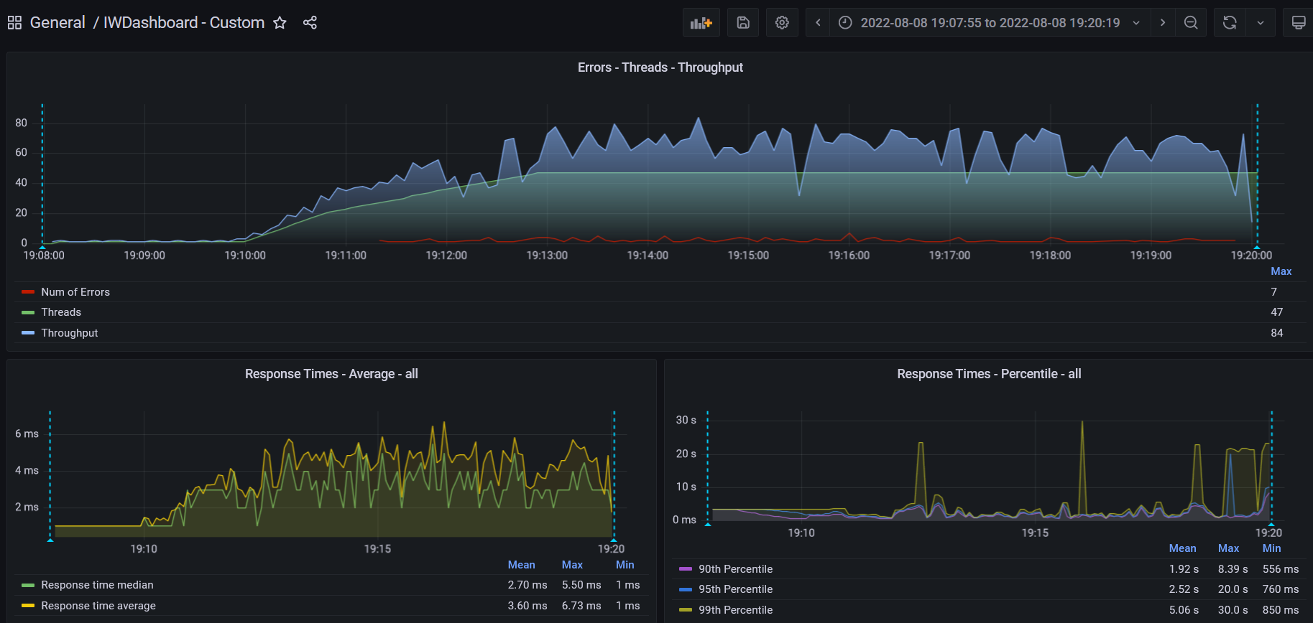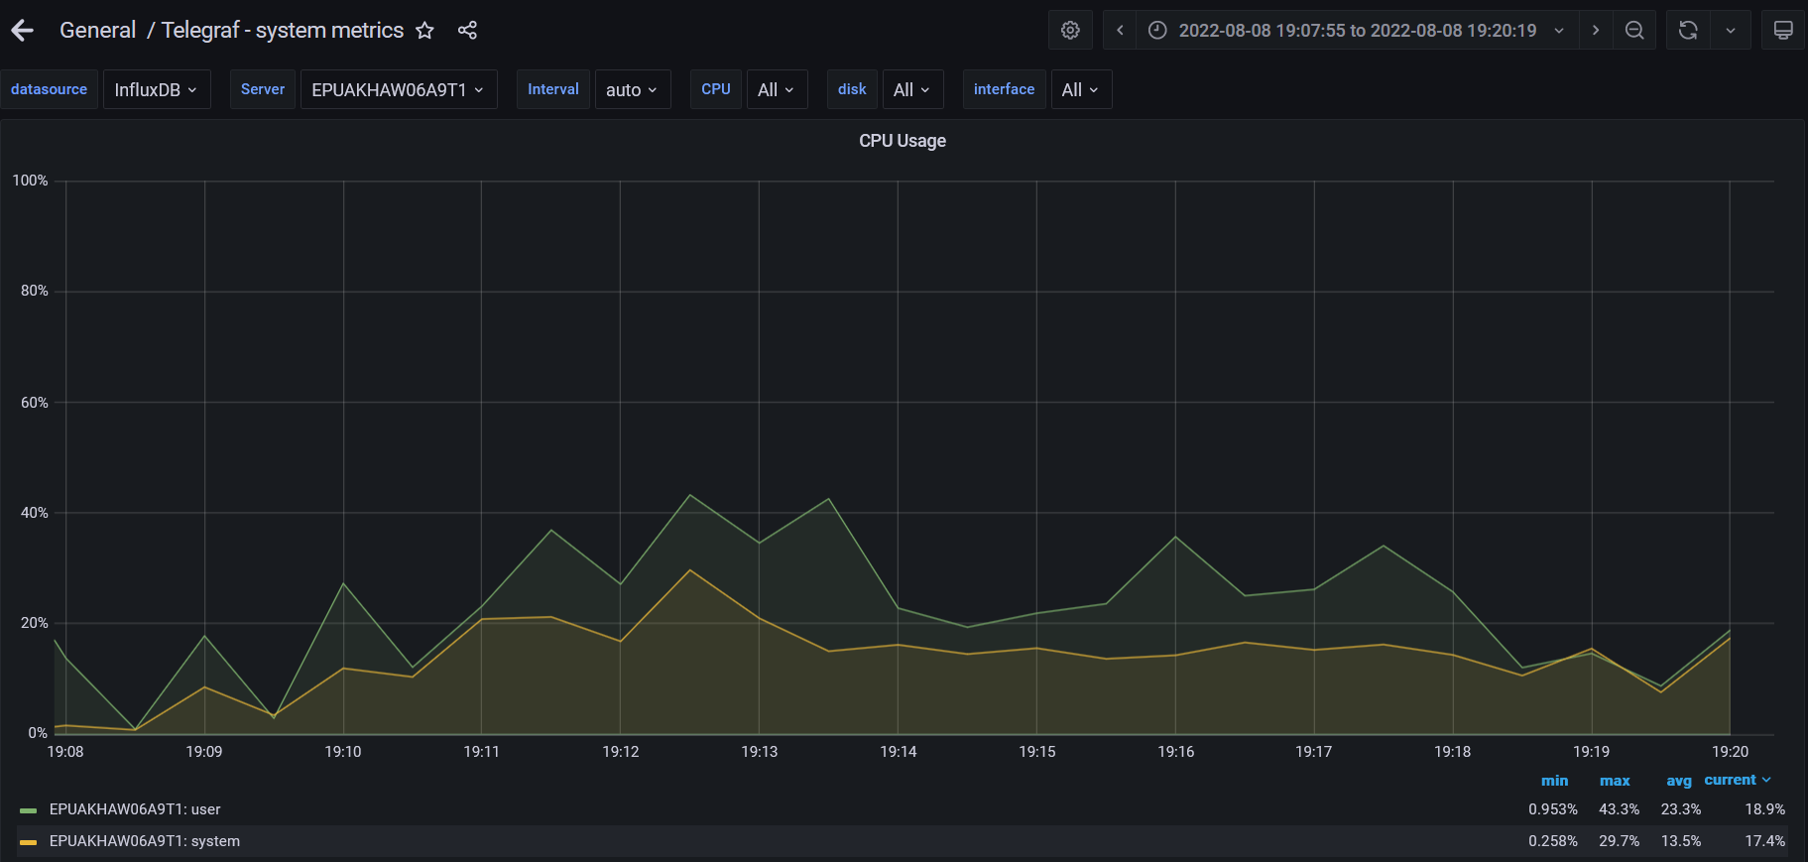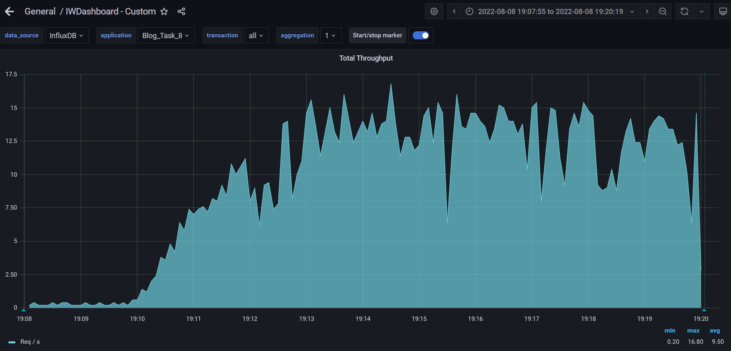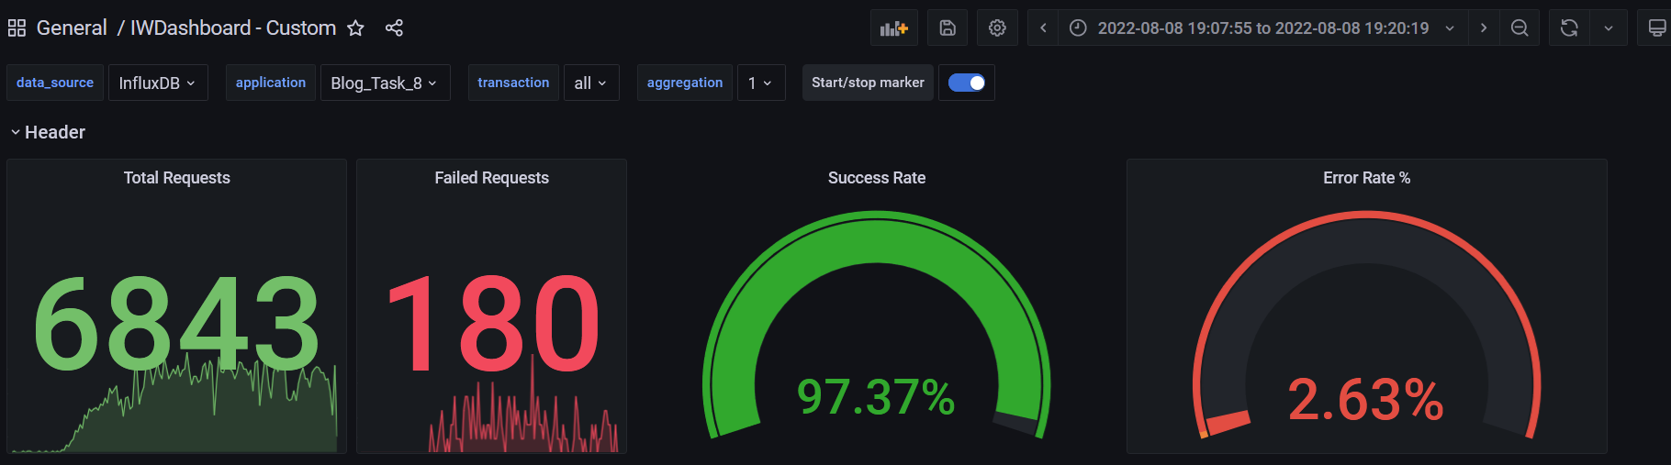

**Test Run #2 (Scale Model 3)**

**Detailed error report**

|  |  |  |
| --- | --- | --- |
| Response Code | Transaction | Error count |
| 500 | Transaction Controller (Open PredefineDate)  Transaction Controller (Open RandomDate)  Transaction Controller (Save Post) | 1  10 |
| 404 | Transaction Controller (Open Home Page Anonymous)  Transaction Controller (Open PredefineDate)  Transaction Controller (Open RandomDate)  Transaction Controller (Search By Name) | 5  5  2  7 |
| Non HTTP response code: java.net.SocketTimeoutException | Transaction Controller (Add User)  Transaction Controller (Edit Post)  Transaction Controller (Open Contacts)  Transaction Controller (Open Date)  Transaction Controller (Open Home Page Anonymous)  Transaction Controller (Open Home Page)  Transaction Controller (Open Large Calendar)  Transaction Controller (Open Post)  Transaction Controller (Open PredefineDate)  Transaction Controller (Open Profile Page)  Transaction Controller (Open RandomDate)  Transaction Controller (Open User Page)  Transaction Controller (Save Post)  Transaction Controller (Search By Name) | 1  4  5  3  16  4  6  4  24  1  8  2  2  23 |
| Non HTTP response code: java.net.URISyntaxException | Transaction Controller (Edit Post) | 4 |

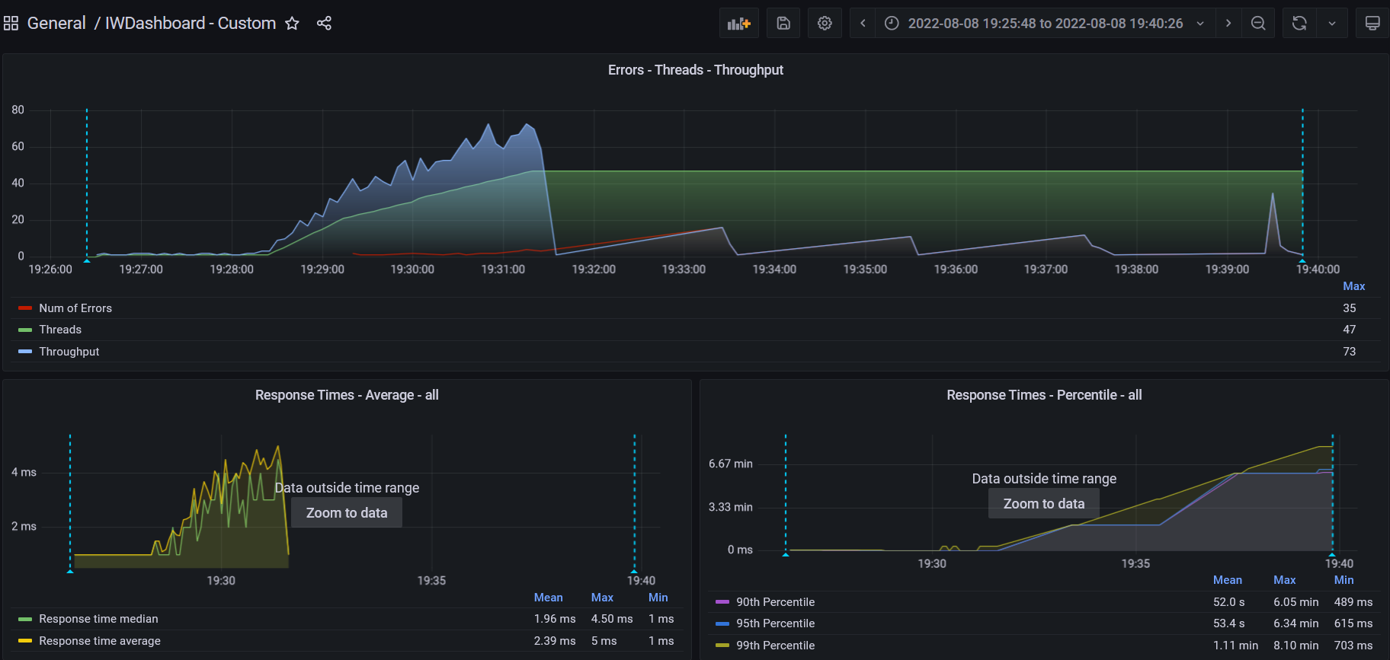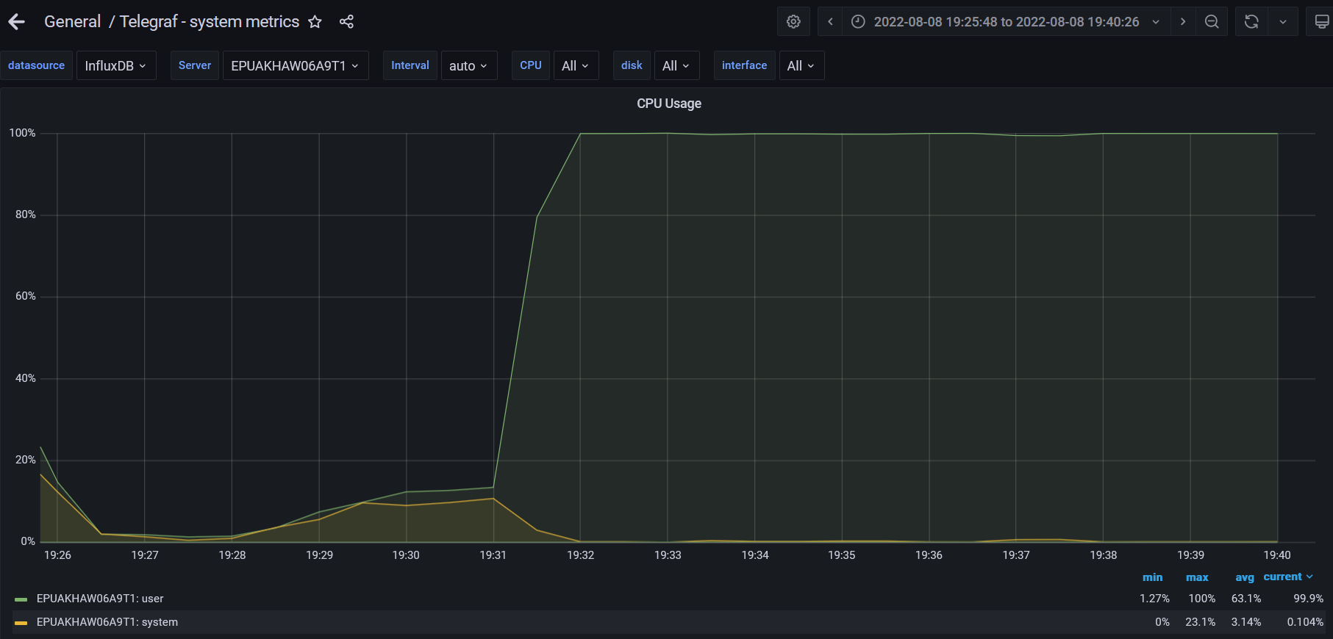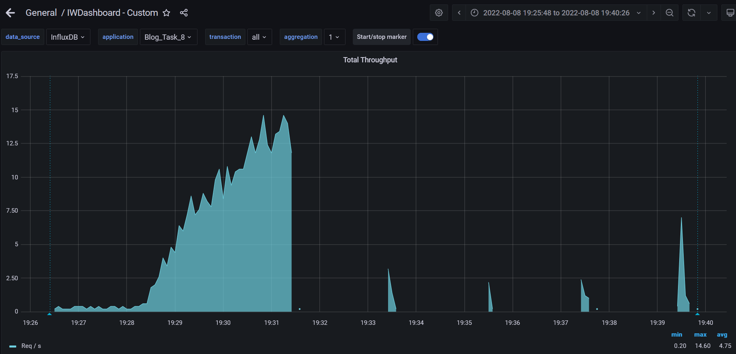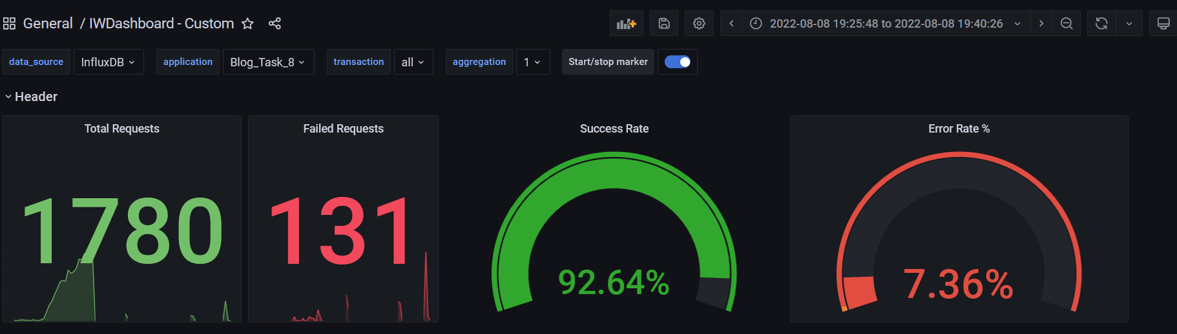

**Test Run #1 (Scale Model 4)**

**Detailed error report**

|  |  |  |
| --- | --- | --- |
| Response Code | Transaction | Error count |
| 500 | Transaction Controller (Open Home Page Anonymous)  Transaction Controller (Open PredefineDate)  Transaction Controller (Open RandomDate)  Transaction Controller (Save Post) | 1  2  2  16 |
| 404 | Transaction Controller (Open Home Page Anonymous)  Transaction Controller (Open PredefineDate)  Transaction Controller (Open RandomDate)  Transaction Controller (Search By Name) | 8  16  8  13 |
| Non HTTP response code: java.net.SocketTimeoutException | Transaction Controller (Edit Post)  Transaction Controller (Open Admin Page)  Transaction Controller (Open Contacts)  Transaction Controller (Open Date)  Transaction Controller (Open Home Page Anonymous)  Transaction Controller (Open Home Page)  Transaction Controller (Open Large Calendar)  Transaction Controller (Open Post)  Transaction Controller (Open PredefineDate)  Transaction Controller (Open Profile Page)  Transaction Controller (Open RandomDate)  Transaction Controller (Open User Page)  Transaction Controller (Save Post)  Transaction Controller (Search By Name)) | 2  1  4  3  11  2  4  6  18  2  7  1  2  22 |
| Non HTTP response code: java.net.URISyntaxException | Transaction Controller (Edit Post) | 6 |

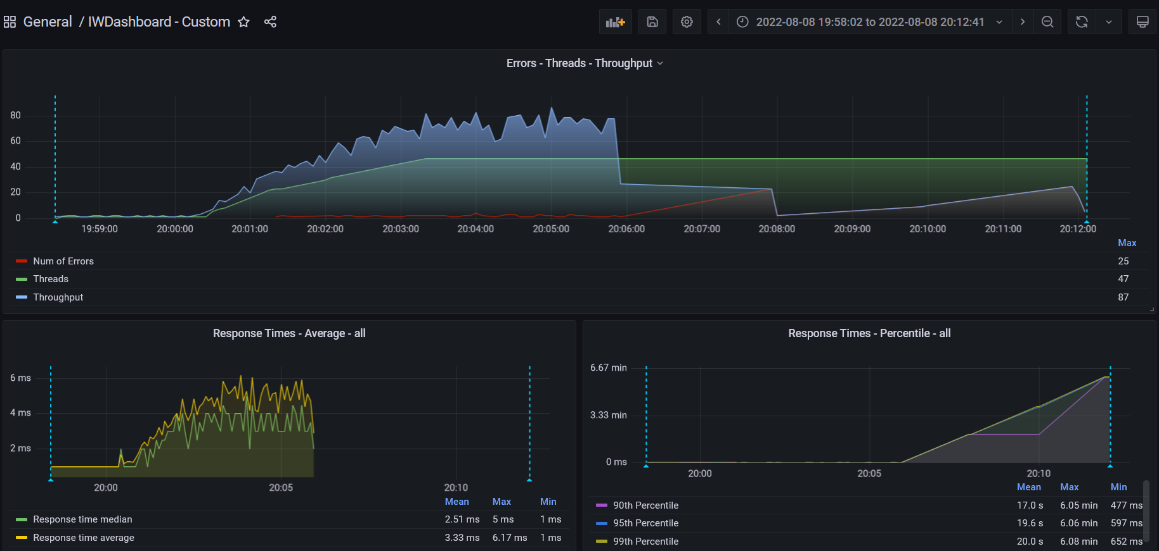

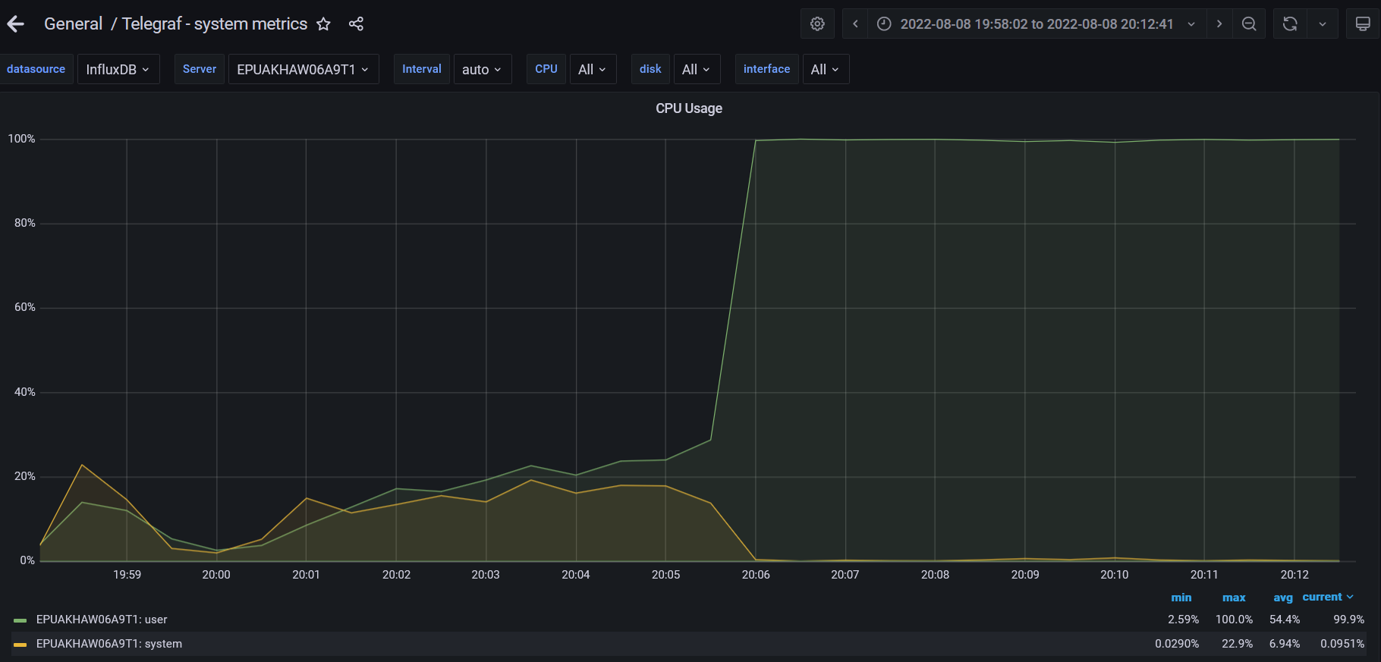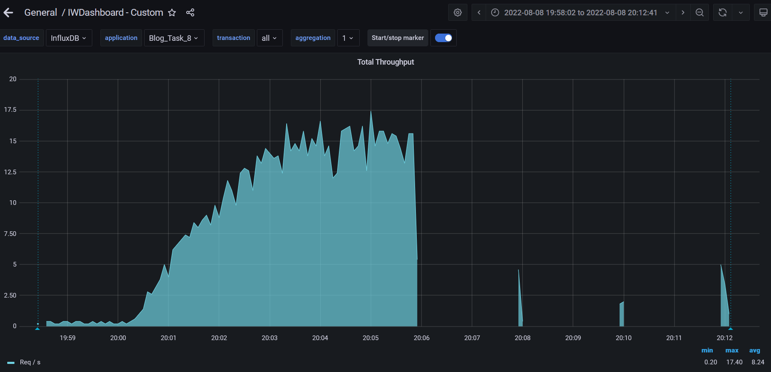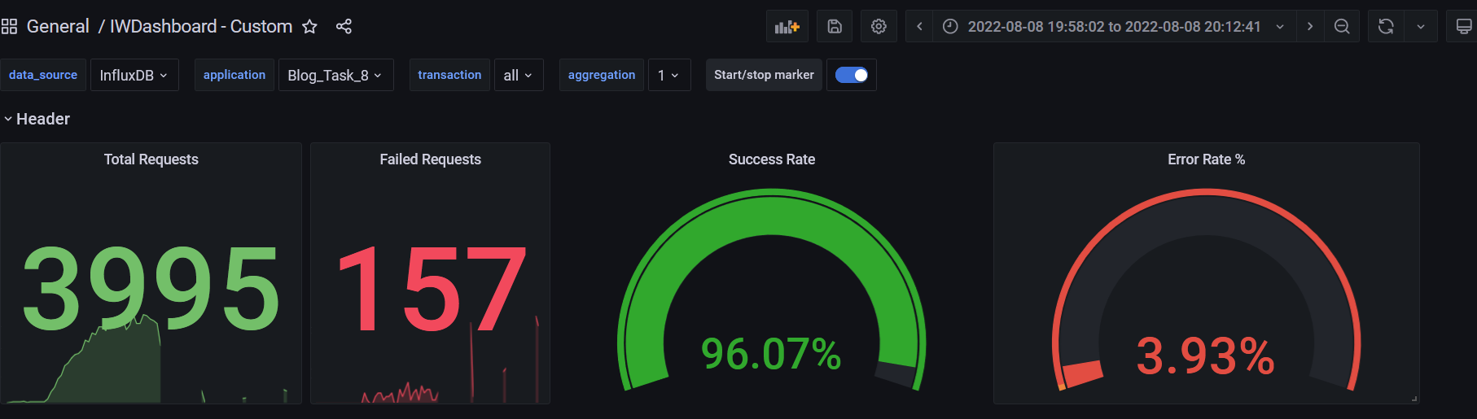

**Test Run #2 (Scale Model 4)**

**Detailed error report**

|  |  |  |
| --- | --- | --- |
| Response Code | Transaction | Error count |
| 500 | Transaction Controller (Open Date)  Transaction Controller (Open Home Page Anonymous)  Transaction Controller (Open Post)  Transaction Controller (Open RandomDate)  Transaction Controller (Save Post)  Transaction Controller (Search By Name) | 1  1  1  1  11  1 |
| 404 | Transaction Controller (Open Home Page Anonymous)  Transaction Controller (Open Post)  Transaction Controller (Open PredefineDate)  Transaction Controller (Open RandomDate)  Transaction Controller (Search By Name) | 4  1  6  5  5 |
| Non HTTP response code: java.net.SocketTimeoutException | Transaction Controller (Edit Post)  Transaction Controller (Open Contacts)  Transaction Controller (Open Date)  Transaction Controller (Open Home Page Anonymous)  Transaction Controller (Open Large Calendar)  Transaction Controller (Open Post)  Transaction Controller (Open PredefineDate)  Transaction Controller (Open Profile Page)  Transaction Controller (Open RandomDate)  Transaction Controller (Open User Page)  Transaction Controller (Save Post)  Transaction Controller (Search By Name) | 1  3  3  9  3  5  21  2  5  2  3  25 |
| Non HTTP response code: java.net.URISyntaxException | Transaction Controller (Edit Post) | 7 |

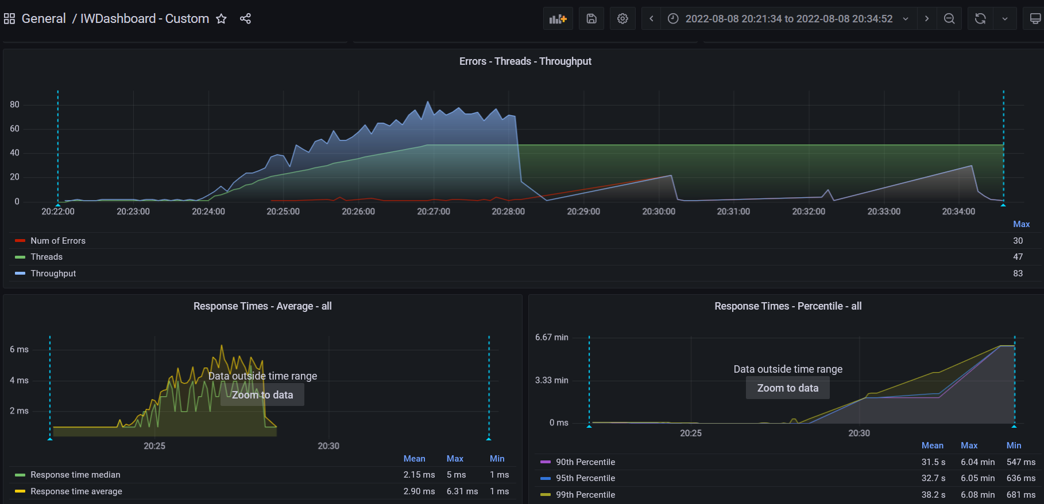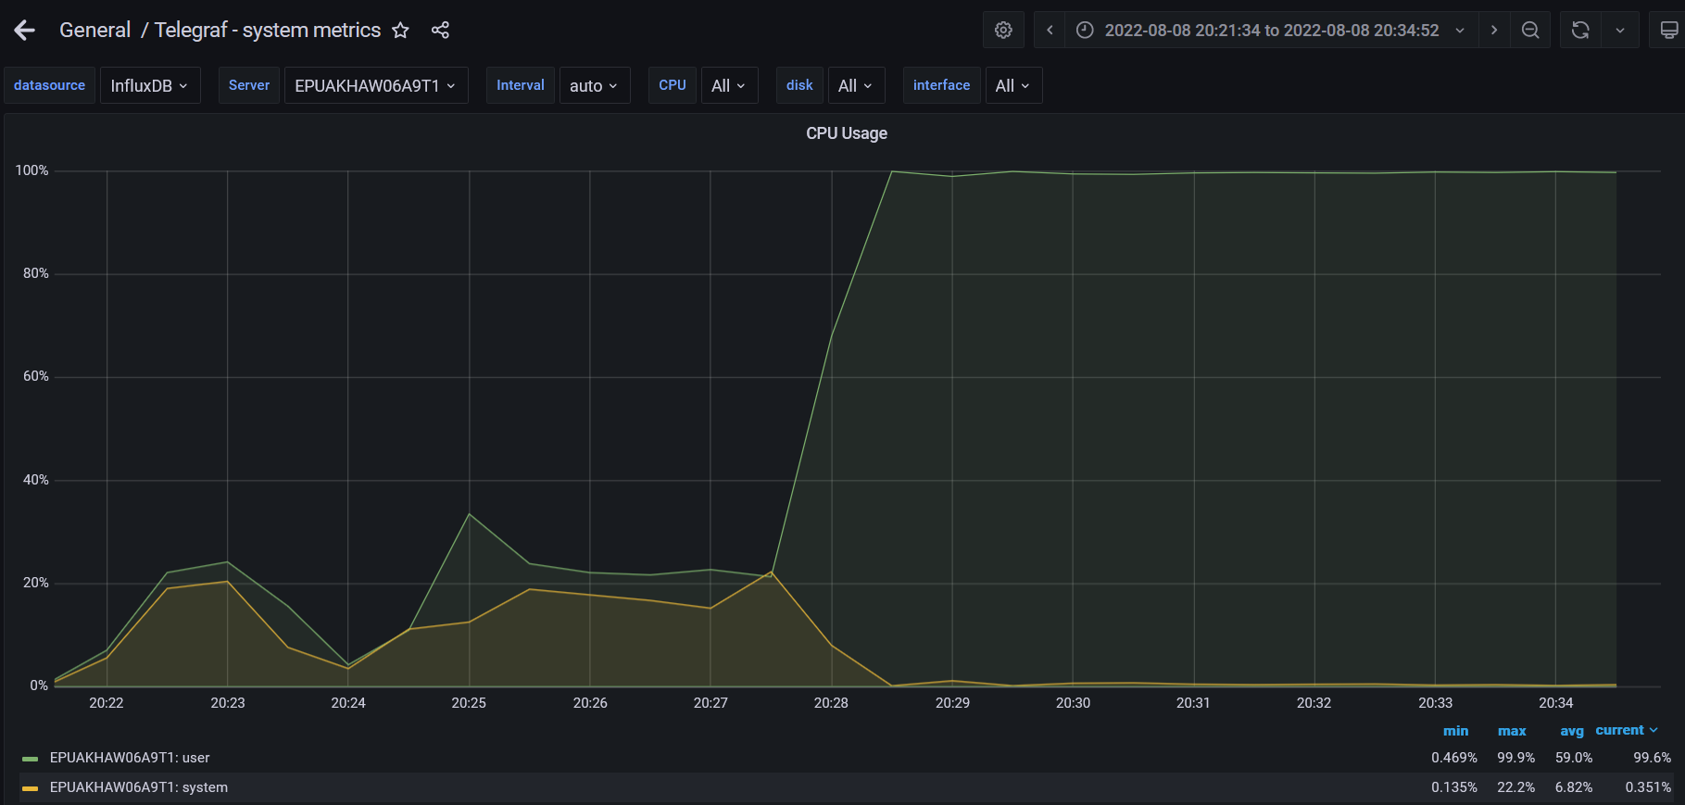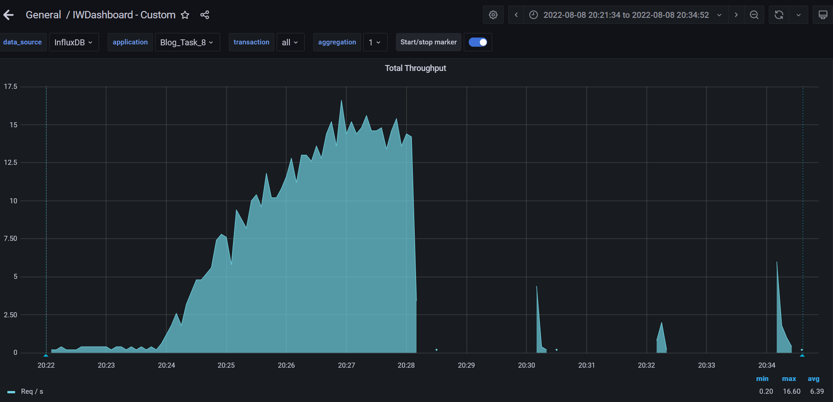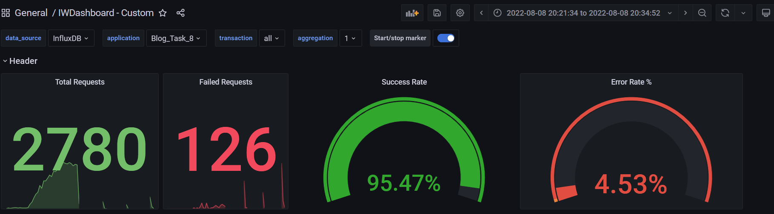

**Test Run #1 (Scale Model 5)**

**Detailed error report**

|  |  |  |
| --- | --- | --- |
| Response Code | Transaction | Error count |
| 500 | Transaction Controller (Open Large Calendar)  Transaction Controller (Save Post) | 1  4 |
| 404 | Transaction Controller (Open PredefineDate)  Transaction Controller (Search By Name) | 4  3 |
| Non HTTP response code: java.net.SocketTimeoutException | Transaction Controller (Add User)  Transaction Controller (Edit Post)  Transaction Controller (Open Contacts)  Transaction Controller (Open Date)  Transaction Controller (Open Home Page Anonymous)  Transaction Controller (Open Home Page)  Transaction Controller (Open Large Calendar)  Transaction Controller (Open Post)  Transaction Controller (Open PredefineDate)  Transaction Controller (Open Profile Page)  Transaction Controller (Open RandomDate)  Transaction Controller (Open User Page)  Transaction Controller (Save Post)  Transaction Controller (Search By Name) | 1  3  3  6  13  7  7  4  23  1  9  2  3  29 |
| Non HTTP response code: java.net.URISyntaxException |  | 4 |

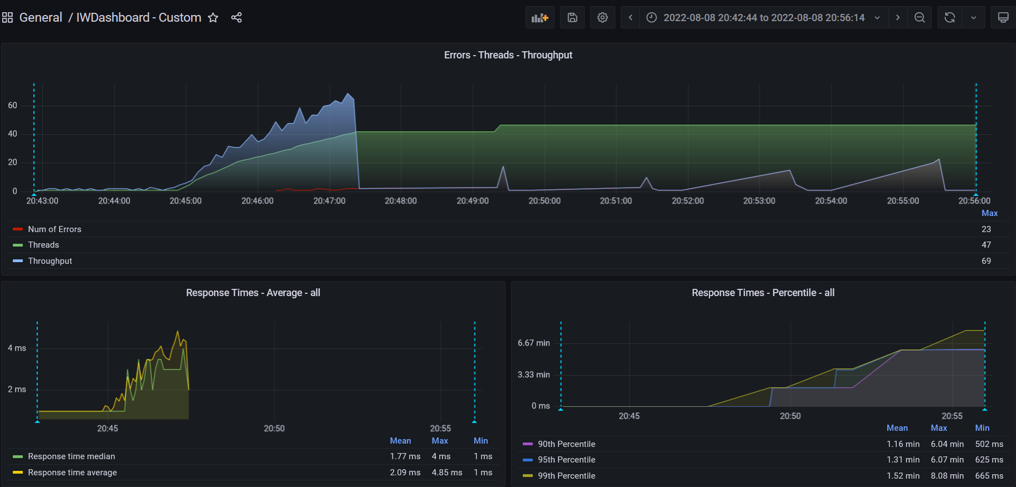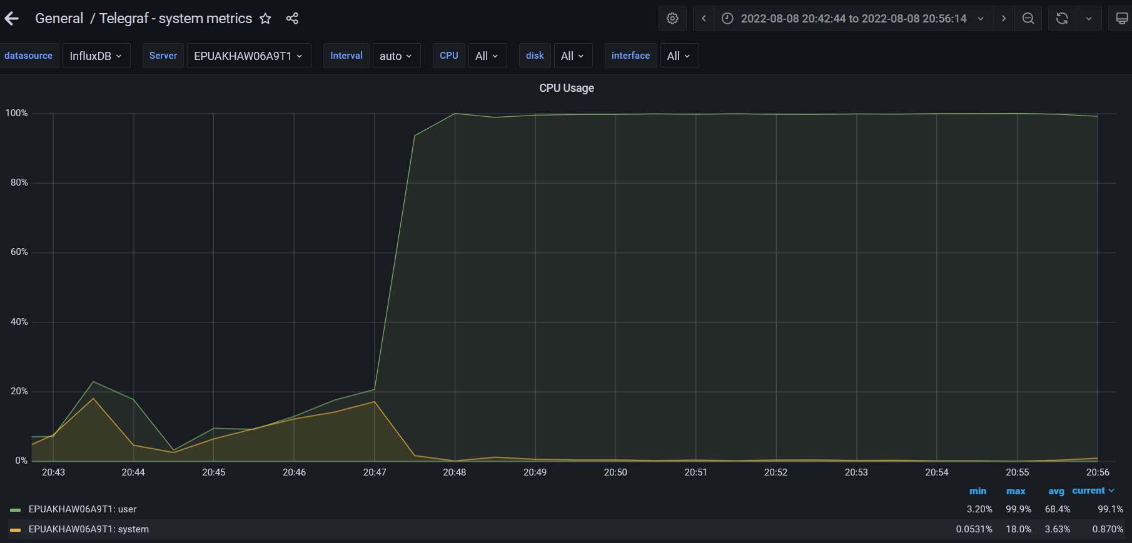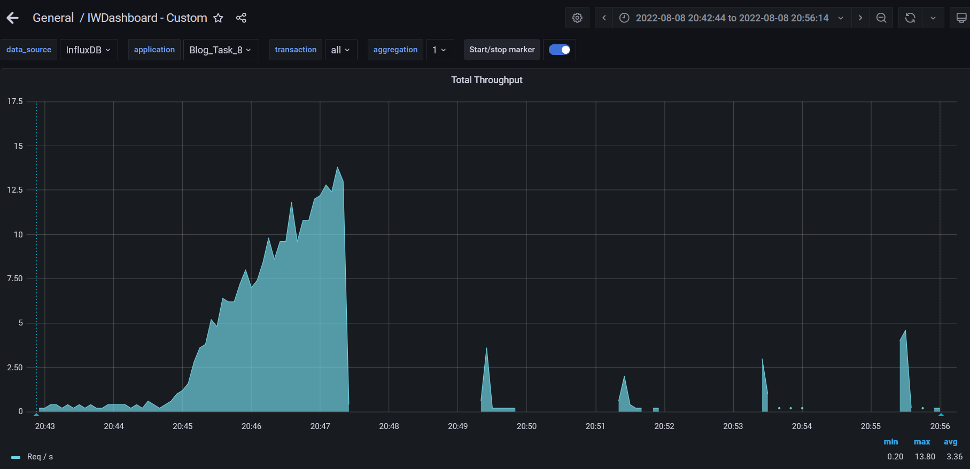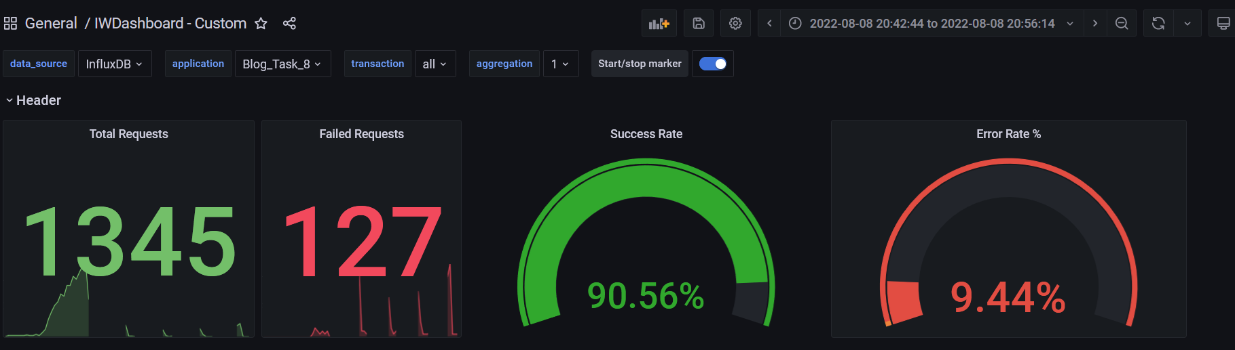

**Test Run #2 (Scale Model 5)**

**Detailed error report**

|  |  |  |
| --- | --- | --- |
| Response Code | Transaction | Error count |
| 500 | Transaction Controller (Open Home Page Anonymous)  Transaction Controller (Save Post) | 1  9 |
| 404 | Transaction Controller (Open Home Page Anonymous)  Transaction Controller (Open PredefineDate)  Transaction Controller (Open RandomDate)  Transaction Controller (Search By Name) | 3  4  4  2 |
| Non HTTP response code: java.net.SocketTimeoutException | Transaction Controller (Add User)  Transaction Controller (Edit Post)  Transaction Controller (Open Contacts)  Transaction Controller (Open Date)  Transaction Controller (Open Home Page Anonymous)  Transaction Controller (Open Home Page)  Transaction Controller (Open Large Calendar)  Transaction Controller (Open Post)  Transaction Controller (Open PredefineDate)  Transaction Controller (Open RandomDate)  Transaction Controller (Open User Page)  Transaction Controller (Save Post)  Transaction Controller (Search By Name) | 2  3  4  5  16  3  7  4  27  7  2  3  26 |
| Non HTTP response code: java.net.URISyntaxException |  | 4 |

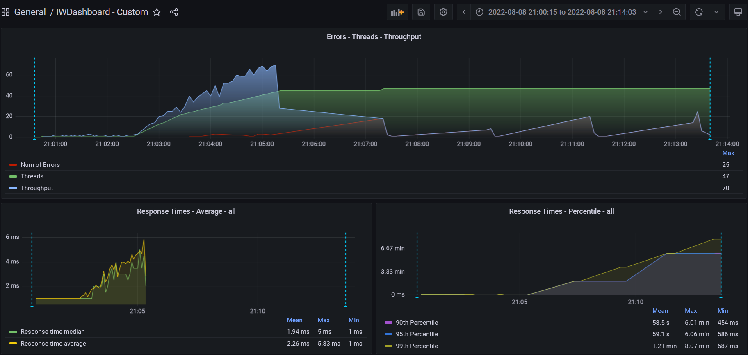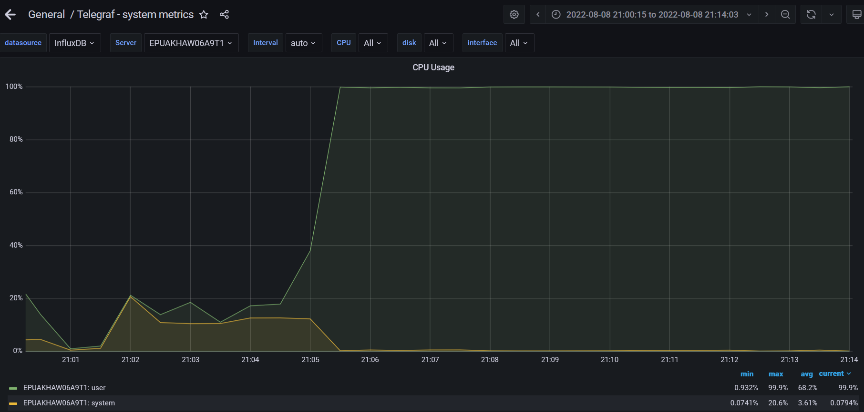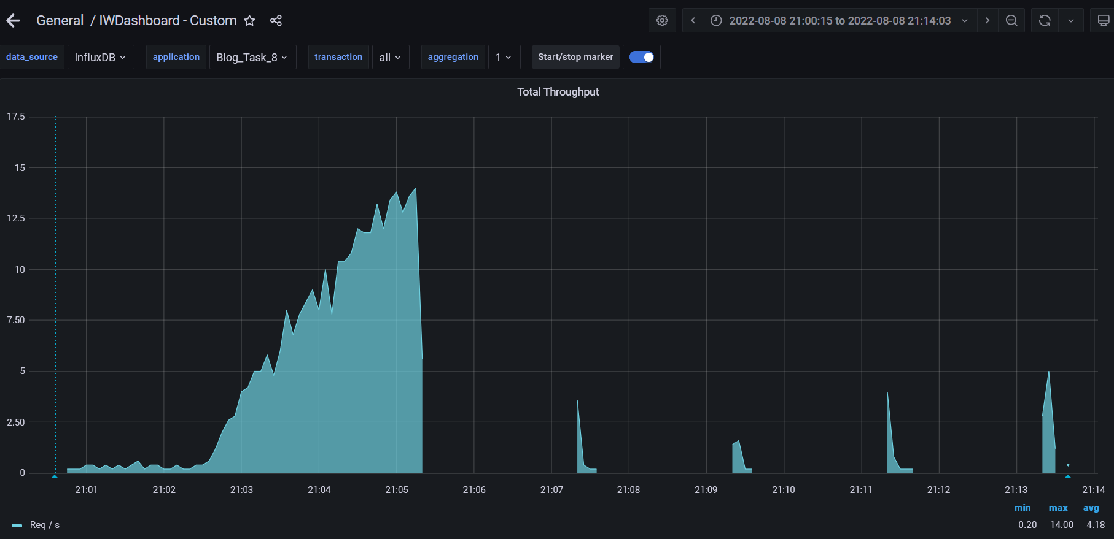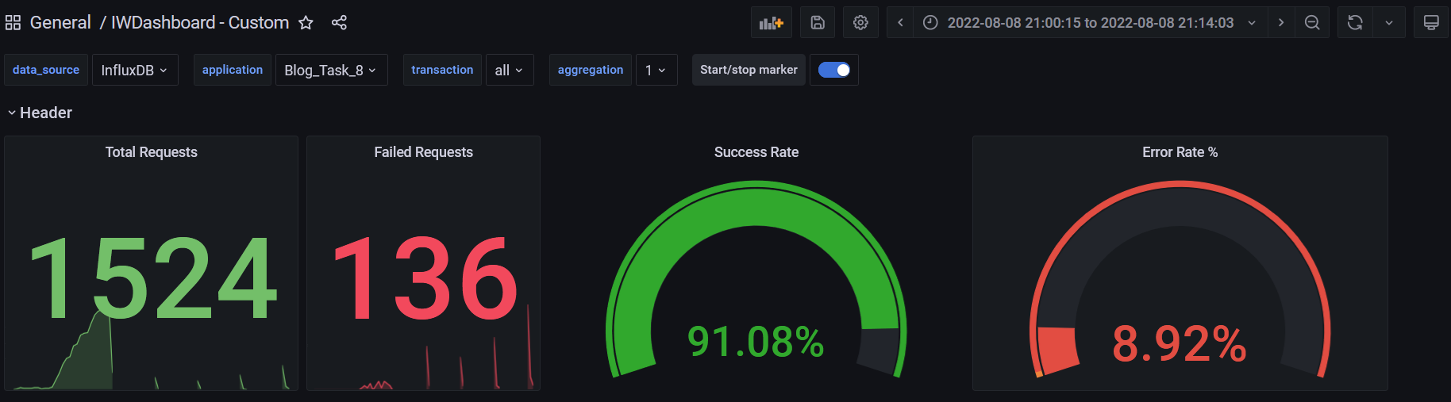

**Test Run #1 (Scale Model 6)**

**Detailed error report**

|  |  |  |
| --- | --- | --- |
| Response Code | Transaction | Error count |
| 500 | Transaction Controller (Open Home Page Anonymous)  Transaction Controller (Open PredefineDate)  Transaction Controller (Open Profile Page)  Transaction Controller (Open RandomDate)  Transaction Controller (Save Post)  Transaction Controller (Search By Name) | 1  2  1  1  17  4 |
| 404 | Transaction Controller (Open Home Page Anonymous)  Transaction Controller (Open PredefineDate)  Transaction Controller (Open RandomDate)  Transaction Controller (Search By Name) | 5  8  3  7 |
| Non HTTP response code: java.net.SocketTimeoutException | Transaction Controller (Edit Post)  Transaction Controller (Login)  Transaction Controller (Open Contacts)  Transaction Controller (Open Date)  Transaction Controller (Open Home Page Anonymous)  Transaction Controller (Open Home Page)  Transaction Controller (Open Large Calendar)  Transaction Controller (Open Post)  Transaction Controller (Open PredefineDate)  Transaction Controller (Open Profile Page)  Transaction Controller (Open RandomDate)  Transaction Controller (Open User Page)  Transaction Controller (Save Post)  Transaction Controller (Search By Name) | 4  1  2  2  11  2  4  5  16  1  8  1  1  20 |
| Non HTTP response code: java.net.URISyntaxException | Transaction Controller (Edit Post) | 5 |

**Test Run #2 (Scale Model 6)**

**Detailed error report**

|  |  |  |
| --- | --- | --- |
| Response Code | Transaction | Error count |
| 500 | Transaction Controller (Open PredefineDate)  Transaction Controller (Save Post) | 1  10 |
| 404 | Transaction Controller (Open Home Page Anonymous)  Transaction Controller (Open PredefineDate)  Transaction Controller (Open RandomDate)  Transaction Controller (Search By Name) | 7  15  2  9 |
| Non HTTP response code: java.net.SocketTimeoutException | Transaction Controller (Add User)  Transaction Controller (Edit Post)  Transaction Controller (Open Contacts)  Transaction Controller (Open Date)  Transaction Controller (Open Home Page Anonymous)  Transaction Controller (Open Home Page)  Transaction Controller (Open Large Calendar)  Transaction Controller (Open Post)  Transaction Controller (Open PredefineDate)  Transaction Controller (Open Profile Page)  Transaction Controller (Open RandomDate)  Transaction Controller (Open User Page)  Transaction Controller (Save Post)  Transaction Controller (Search By Name) | 1  3  5  2  7  2  4  5  18  1  8  2  2  19 |
| Non HTTP response code: java.net.URISyntaxException | Transaction Controller (Edit Post) | 5 |

1. **Conclusion:**

The server worked stable with 1 CPU, in case of 2,3 CPUs viewed unstable server work. according to the received test results by 6 runs for 1,2,3 CPU, the best result was defined for 1 CPU and the “Error rate” was 0%, in the case of 2,3 CPUs test results were unstable and the “Error rate” grew to approximately 10%. CPUs were growing to 100% the quantity of user requests is falling after reaching server timeout. The next 6 runs use params with 2,4,8 GB RAM and 2 CPUs. The main issue is using the system with more than 1 CPU, scaling of the quantity of RAM has no significant influence on system work. The appropriate parameters for server work are 1 CPU and 8GB of RAM.